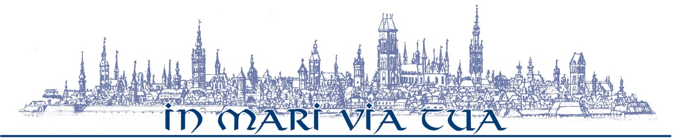
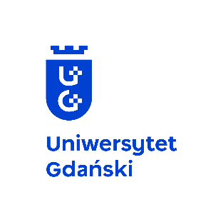

National Quantum Information Centre in Gdańsk (KCIK) &
International Centre for Theory of Quantum Technologies (ICTQT)
____________________________________________________________________

13th Symposium KCIK- ICTQT on Quantum Information, MAY 26-28, 2022,
Sopot, ul. Armii Krajowej 119, Faculty of Economics UG (Building C, Hall D)

PROGRAM

Thursday, May 26

08:30 – 09:00 | Registration
09:00 – 09:10 | Opening ceremony  Wiesław Laskowski, Vice-Rector for Research, University of Gdańsk  Marek Żukowski, Organising Committee, Director of ICTQT, University of Gdańsk  Karol Życzkowski, Chair of the Symposium, Director of KCIK University of Gdańsk, Jagiellonian University, CTP Polish Academy of Sciences, Warsaw
Session I | Chair: Adam Miranowicz
09:10 – 09:35 | Konrad Banaszek | Secure optical communication under restricted eavesdropping scenarios
09:40 – 10:05 | Jan Sperling | Many colors of entanglement
10:10 – 10:35 | Alejandro Jenkins | Quantum thermodynamics of coronal heating
10:40 – 11:10 | Coffee break
Session II | Chair: Jakub Rembieliński
11:10 – 11:35 | Beatrix C. Hiesmayr | About bound entanglement
11:40 – 12:05 | Armin Tavakoli | Informational restrictions in quantum correlations
12:10 – 12:35 | Marek Mozrzymas/  Piotr Kopszak | Square-root measurement and the degradation of the resource state in the deterministic port-based teleportation scheme
12:40 – 14:00 | Lunch

Session III | Chair: Karol Życzkowski
14:00 – 14:25 | Michail Skoteiniotis | Certifying topological states of matter
14:30 – 14:55 | Michał Oszmaniec | Saturation and recurrence of quantum complexity in random quantum circuits
15:00 – 15:25 | Volodymyr Tkachuk (online) | Spin system energy levels detection on a quantum computer
15:30 – 16:00 | Coffee break
Session IV | Chair: Katarzyna Roszak
16:00 – 16:25 | Paweł Caban | Nonlinear extension of the quantum dynamical semigroup
16:30 – 16:55 | Janet Anders (online) | Quantum Brownian Motion for Magnets
17:00 - 17:25 | Lorenza Viola (online) | Restoring superclassical precision scaling in quantum frequency estimation under spatiotemporally correlated quantum noise
18:00 – 20:30 | Dinner (Dinner speech: Artur Ekert)

Friday, May 27

Session V | Chair: Beatrix C. Hiesmayr
09:00 – 09:25 | Berthold-Georg Englert | Sequentially constrained Monte Carlo sampler for quantum states
09:30 – 9:55 | Yeong-Cherng Liang | Naturally restricted subsets of nonsignaling correlations: how different are they?
10:00 – 10:25 | Rafał Demkowicz-Dobrzański | Fundamental Limits in Mutiparameter Quantum Metrology
10:30 – 10:55 | Felix Huber | Dimension-free entanglement detection in multipartite Werner states
11:00 – 11:30 | Coffee break
Session VI | Chair: Łukasz Rudnicki
11:30 – 11:55 | Adam Miranowicz | Non-Hermitian quantum mechanics: No-go theorems and quantum exceptional points
12:00 – 12:25 | Katarzyna Roszak | A measure of qubit environment entanglement for pure dephasing evolutions
12:30 – 13:15 | Golden KCIK Award  S.A. Rather (online)/  Adam Burchardt | Thirty-six entangled officers of Euler: Quantum solution to a classically impossible problem
13:20 – 14:30 | Lunch

Session VII | Chair: Marek Żukowski
14:30 – 14:55 | Mohamed Bourennane | Stronger correlations than dense coding with elementary quantum resources
15:00 – 15:25 | Tomasz Placek | Chance and choice: On experimenters' free choice and deterministic hidden-variable models
15:30 – 15:55 | Mark Hillery (online) | Quantum walks and path finding
16:00 – 16:30 | Coffee break
Session VIII | Chair: Yeong-Cherng Liang
16:30 – 16:55 | Ana Belén Sainz | Steering: a modern perspective on this fundamental puzzle
17:00 – 17:25 | Dardo Goyeneche (online) | The classical value of Bell inequalities: an old problem in mathematics
17:30 – 17:55 | Lukas Céleri (online) | Gauge theory approach to quantum thermodynamics

Saturday, May 28

Session IX | Chair: Berthold-Georg Englert
09:15 – 9:40 | Marek Czachor | Cosmic-time Quantum Mechanics
9:45 – 10:10 | Kavan Modi (online) | Linking many-body physics to many-time physics: Characterising micro and macro features of non-Markovian quantum processes
10:15 – 10:40 | Michele Dall’Arno (online) | Guesswork of a quantum ensemble
10:45 – 11:15 | Coffee break
Session X | Chair: Krzysztof Kowalski
11:15 – 11:40 | Marek Żukowski | On absurdity of some interpretations of Wigner's Friend gedanken-experiment
11:45 – 12:10 | Massimo Palma (online) | Non-locality breaks the relations between measures of quantum objectivity
12:15 – 12:40 | Dariusz Chruściński | Universal Constraint for Relaxation Rates for Quantum Dynamical Semigroup
12:40 – 14:00 | Lunch
14:00 – 15:00 | KCIK board meeting

